Online grocery Data Flow Diagram

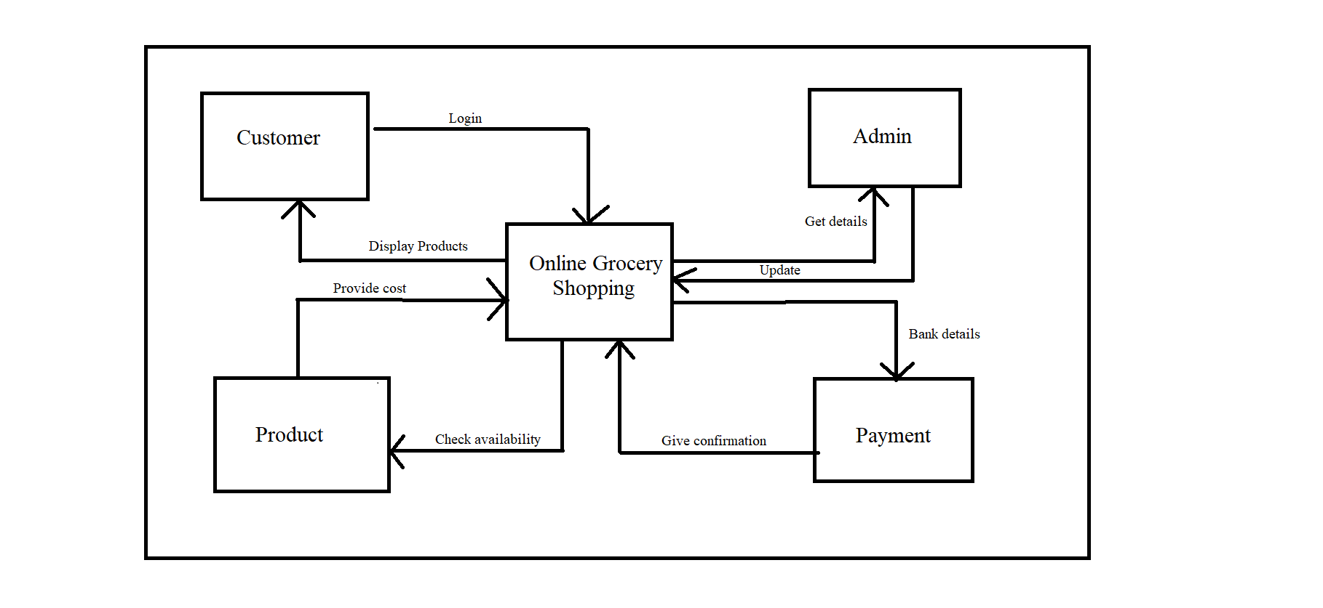

Customer Data flow diagram

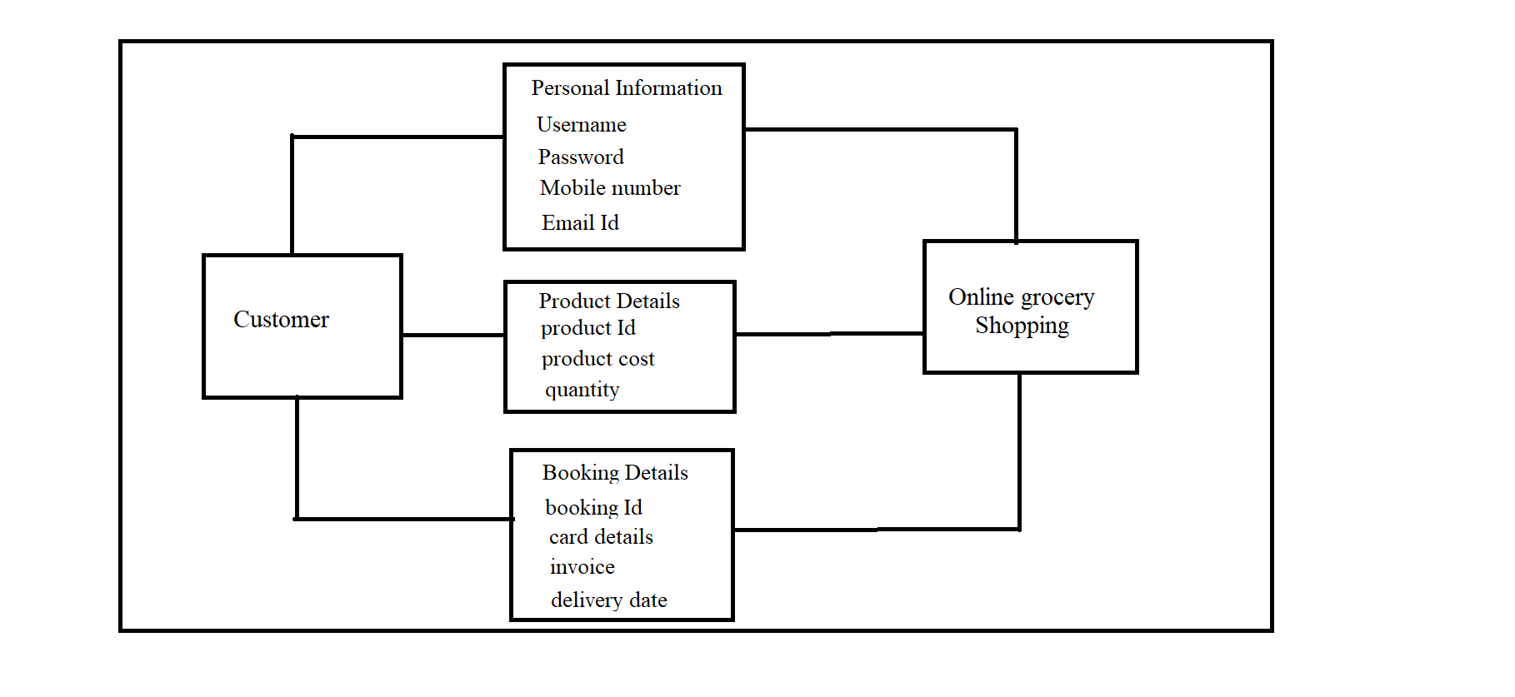

Admin Data flow diagram

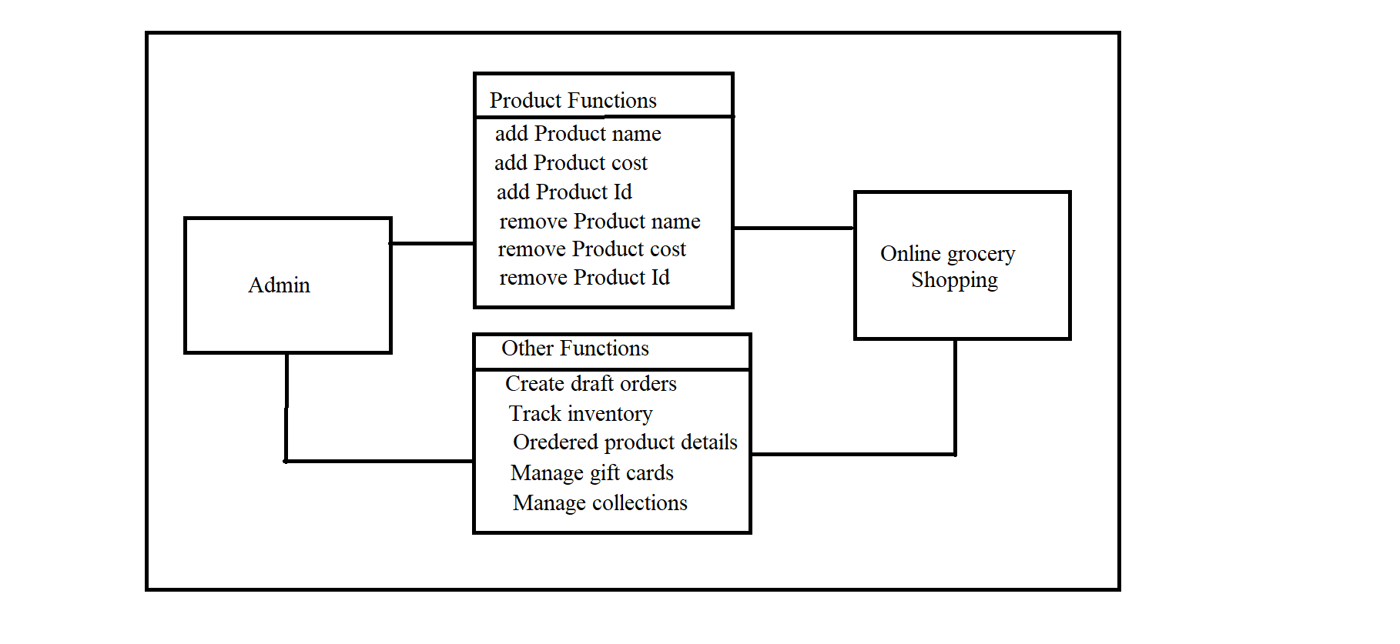

Online Shopping E-R-Diagram

Customer: -

CustomerDetails

ProductDetails

PaymentDetails

BookingDetails

Admin: -

AdminDetails

Add Products

Remove Products

Product Tracking

Gift Cards

